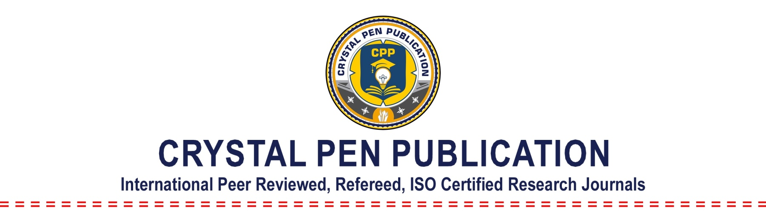
Conference Proceeding Agreement

1. Parties Entering into the Agreement:

This agreement is entered into between the following parties:

Crystal Pen Publication, Perambalur, Tamil Nadu, India - www.crystalpen.in

&

Title of the Conference
Date of the Conference
Name of the Organizer
Institute / University
Name of the Department
Name of the Head / Principal
(By Sign Agreement with College / Department / Institute Seal)
Email
Contact Number
Address
Journal Name: IJMRME / IJERME / IJCRME / IJSRME (Choose the Journal)

2. Purpose of the Agreement:

The above Organizer / Institute / University must agree with IJMRME / IJERME / IJCRME / IJSRME for publishing the research article / paper of above title conference in IJMRME / IJERME / IJCRME / IJSRME conference proceeding publication.

3. Terms and Condition of Agreement:

- The conference organizer should provide the manuscripts in doc format to the editor of IJMRME / IJERME / IJCRME / IJSRME.
- The format of the manuscript must comply with the template of IJMRME / IJERME / IJCRME / IJSRME available on the website.
- Organizer must be submitted the signed scan copy of copyright form provided by IJMRME / IJERME / IJCRME / IJSRME or available on website, this agreement treated as copyright transfer of all papers for conference proceeding.
- If any complaint is received about the journal on the basis of this agreement editor has right to take action.
- The conference organizers are also submitting the review comments and the list of reviewers to IJMRME / IJERME / IJCRME / IJSRME along with the manuscripts.
- IJMRME / IJERME / IJCRME / IJSRME will publish the selected manuscripts in conference proceeding after receiving all copyright forms of paper. If organizer did not submit the copyright form of any selected paper; IJMRME / IJERME / IJCRME / IJSRME will not publish the paper in conference proceeding.
- Organizer can submit the list contain details; Title of paper, Authors name (first, second & third), Email, Full Postal address of first author.
- IJMRME / IJERME / IJCRME / IJSRME will publish all papers in the special issue after the conference.
- Organizer must be conforming about submitted manuscripts not caught in plagiarism in evaluation process of IJMRME / IJERME / IJCRME / IJSRME. If any manuscript is caught in plagiarism, IJMRME / IJERME / IJCRME / IJSRME will not publish that paper and without informing to organizer IJMRME / IJERME / IJCRME / IJSRME will remove that paper from publication process.
- Publication process of IJMRME / IJERME / IJCRME / IJSRME for conference proceeding will be finished after minimum 15-30 days from the date of submission of all manuscripts and copyright form.
- IJMRME / IJERME / IJCRME / IJSRME will publish all paper after receiving complete payment as per number of paper submitted by organizer.
- Organizer submits the final amount with all paper and copyright form, within 15 days after the conference finished.
- Organizer must submit all manuscripts and copyright form at one time.
- Hard copy of publication certificate and journal are not provided for the special issue publication of the conference.
- If conference organizer wants to provide the hard copy of publication certificate (all authors) and journal (one copy) to all the authors for the published papers, then they have to pay the extra charges Rs. 500 per paper.
- All the rule of copyright form applies for conference proceeding, and all authors must be accepting to that rules and policies which should be noted by organizer of conference.
- IJMRME / IJERME / IJCRME / IJSRME charges Rs. 500 as publication fee per paper.
- The conference organizer must send atleast 40 papers for publication. If it is less than 40 papers minimum Rs. 20000 will be charged by IJMRME / IJERME / IJCRME / IJSRME for publication.
4. Non Refundable Deposit:

- Organizer has to pay the non refundable amount of Rs. 1000 to IJMRME / IJERME / IJCRME / IJSRME. It is the confirmation of tie-up of conference with IJMRME / IJERME / IJCRME / IJSRME.
- Deposit charges from organizing team other than the publication charges.
- Organizer needs to send the deposit amount and scan copy of signed agreement for tie-up of the conference.

5. Termination and Effect of Termination:

- If organizer wants to break the tie-up with IJMRME, the deposit amount Rs. 1000 will not be refunded to the organizer of the conference.
- Non refundable amount Rs. 1000 will not be deducted from total amount of publication charges.
- If the IJMRME / IJERME / IJCRME / IJSRME reviewer’s team identifies plagiarism in any selected paper then the paper will be removed from the process of publication, without informing the organizer.
- If in any circumstance information provided by organizer found false agreement will be terminated and all paper remove from publication process or remove published special issue and legal actions will be taken against the organizer.
- All the information provided by the above by the undersign organizer of conference must be corrected, any false notation give the rights to IJMRME / IJERME / IJCRME / IJSRME to take strict and legal action.
- All the policies and rule of IJMRME / IJERME / IJCRME / IJSRME must be accepted by the organizer of conference, IJMRME / IJERME / IJCRME / IJSRME reserves the rights to make changes in policies time to time and all the changes are made by IJMRME / IJERME / IJCRME / IJSRME time to time must be accepted by the undersign organizer of conference.

Head / Principal
Signature of Organizer with Organization Seal

